Experiment 8: Nmap Service Version and OS Detection in Kali Linux
Aim
To execute Nmap commands in Kali Linux to detect service versions, perform an aggressive scan, and identify the operating system of a target machine.
Algorithm
- Start the Kali Linux operating system and open the terminal.
- Check whether Nmap is installed. If not, install it.
- Select the target IP address of the machine you are authorized to scan.
- Execute the service version detection command.
- Execute the aggressive scan command.
- Execute the operating system detection command.
- Observe and record the output displayed in the terminal.
Commands and Use of Commands
i) Detect the version of services running
Command:
nmap -sV 127.0.0.1
Use of command:
- nmap starts the network scanning tool.
- -sV detects service versions on open ports.
- 127.0.0.1 represents the local Kali Linux machine.
Sample output:
Starting Nmap
Nmap scan report for localhost (127.0.0.1)
Host is up.

PORT STATE SERVICE VERSION
22/tcp open ssh OpenSSH
80/tcp open http Apache httpd

Nmap done: 1 IP address scanned
Note: This is illustrative output. Actual ports and versions depend on the services running on your machine.
ii) Aggressive scan
Command:
nmap -A 127.0.0.1
Use of command:
The -A option enables multiple detection features, including:
- Operating system detection
- Service version detection
- Default script scanning
- Traceroute where supported
Sample output:
Starting Nmap
Nmap scan report for localhost (127.0.0.1)
Host is up.

PORT STATE SERVICE VERSION
22/tcp open ssh OpenSSH

Service detection performed.
Nmap done: 1 IP address scanned
Note: The displayed service is an example. Your results may differ.
iii) Detect operating system of the target
Command:
sudo nmap -O 127.0.0.1
Use of command:
- sudo runs the command with administrator privileges.
- -O enables operating system detection.
- Nmap analyzes network responses to estimate the target's operating system.
Sample output:
Starting Nmap
Nmap scan report for localhost (127.0.0.1)
Host is up.

OS detection performed.
No exact OS matches for host

Nmap done: 1 IP address scanned
Note: OS detection on 127.0.0.1 may be inconclusive. Scanning another authorized machine with suitable network responses may provide better results.
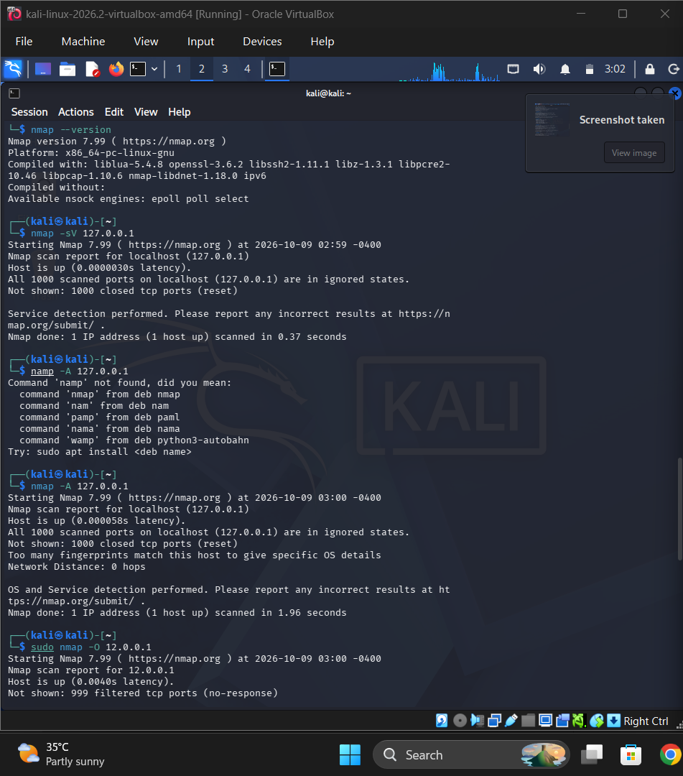
Result
Nmap commands were used to demonstrate service version detection, aggressive scanning, and operating system detection in Kali Linux. The -sV option identifies service versions, -A performs an aggressive scan, and -O attempts to identify the target operating system.

